IKEA Eastern Style Bed

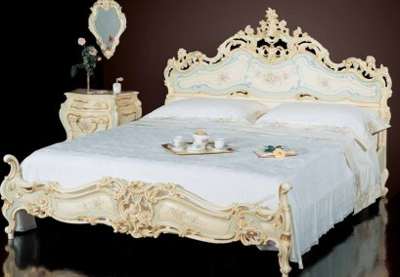

|  |
| --- |
| **DESCRIPTION** |
| IKEA introduces bed with a polyester wood with termite free T poison phosphorus rusts. This set of bed is sure to create the perfect look in flats where termites are constantly present. The rich wood is perfect for the use of forest located areas. For any room of the house, your guests will love this comfortable mood lifting bed. |

|  |  |  |
| --- | --- | --- |
| **Price** | **3300$** | |
| **Dimensions** | **H** x **W** x **L** | **30in x 40in x 75in** |
| **Features** | **Termites are constantly found on areas where there are a lot of trees and medicines used are dangerous for the health of other living beings but phosphorus is environmental friendly it has only one purpose to kill termites.** | |
| **Finished** | **Polished Brown Surface** | |
| **Available in** | **Orange, Off white and Red** | |